**Project Title: ‘**Medical Inventory Optimization’

**EDA/Descriptive Statistics:**

**Introduction:**

Medical inventory refers to the comprehensive collection of medicines, medical devices, instruments and supplies that healthcare facilities maintain to ensure the smooth and effective delivery of healthcare services. By optimization of these inventory levels we aim to reduce wastage, lower costs, improve service levels and ensure the ready availability of essential medical supplies. Through this project we will gain valuable insights by leveraging analytical techniques.

**Methodology:**

The data which was extracted consisted of more than 10,000 records which covers information related medical inventory sales of the year 2022.After Data Collection I have imported the dataset into SQL server to perform exploratory data analysis.

Before performing EDA I have cleaned the data to improve its quality. Then Based on insights from EDA I derived both statistical and business insights which are used to decide which stock intake should be maximized and which stock intake should be minimized to gain maximum profit.

**Data Overview:**

Data which is extracted consists of 14218 observations and 14 attributes

The sample data is given below:

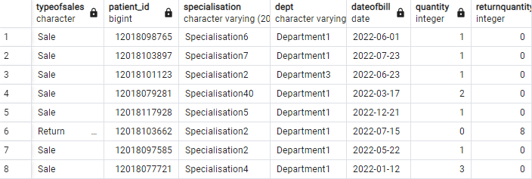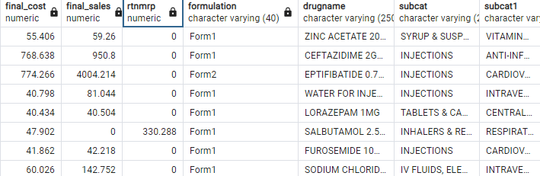

**Data Cleaning:**

In the dataset there are 1668 null values if they are not treated they may lead to inaccurate outcomes so these null values are removed.

After performing Data cleaning I have performed EDA to derive statistical insights and business insights.

In the dataset I observed that there are 3 departments and 58 Specializations.

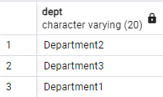

**STATISTICAL INSIGHTS**

The statistical insights derived from the dataset are mentioned below:

1)Mean, Minimum, Maximum, and standard deviation of quantity attribute

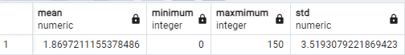

This shows that on an average 2 quantities are purchased, maximum 150 quantities and obtained standard deviation value 3.519.

2)Correlation of two attributes Final_ Sales and Quantity represents relation between them

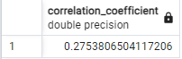

This shows that there is a positive correlation between final_sales and quantity i.e., if final sales increases quantity also increases.

3)Skewness and Kurtosis:



From skewness value we can observe that Quantity column is highly skewed distribution and From kurtosis value we can say that Quantity data has extremely heavy tails it indicates that data has significant outliers.

**BUSINESS INSIGHTS**

**Question:** Which Department has Highest sales?

**Answer:** The output obtained is given below:

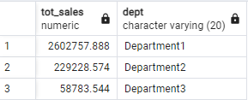

This result gives the information that Department1 has highest sales compared to departments 2 and 3.

**Question:** Which Drugs contribute to maximum sales?

**Answer:** The output obtained is given below:

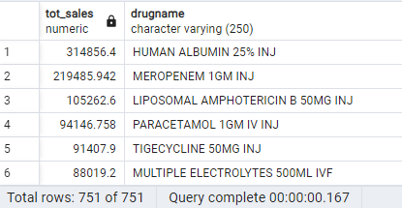

This result shows that the drug HUMAN ALBUMIN 25% INJ contribute to maximum sales. So this drug’s stock intake should be maximized to increase the total sales and avoid stock out.

**Question:** Which Drug has minimum sales?

**Answer:** The output obtained is given below:

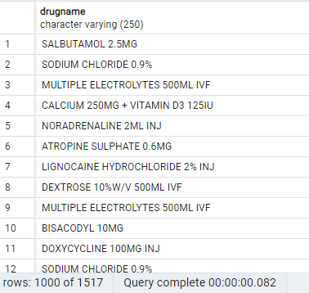

This result shows that these drugs do not contribute much to the sales so these drugs stock intake should be minimized to avoid overstock.

**Question:** Which medicines are mostly returned by consumers or patients?

**Answer:** The output obtained is given below:

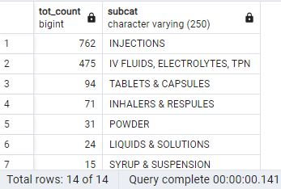

This result shows that Injections are the highest medicines returned by patients or customers so injections need to be replaced by another item for maximum profit.

**Question:** Which specialization has highest sales?

**Answer:** The output obtained is given below:

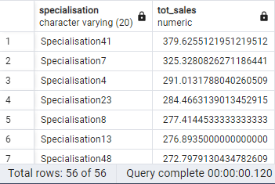

This shows that specialization 41 has highest sales so this stock intake should be maximized.

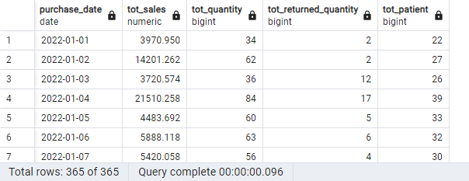

This result gives the information about the total sales, total quantity bought, total quantity returned, and patient according to date.

**Conclusion:**

Medical inventory optimization project was initiated with the primary objectives of reducing wastage, minimizing costs, and ensuring the consistent availability of essential medical supplies for our healthcare facility. The process involved assessing current inventory practices, analyzing available data, and implementing a series of strategic measures to enhance our inventory management system.

With continuous monitoring and a commitment to improvement, we aim to set new benchmarks in medical inventory management.